Student Council - Sgt. Robert D. Gautreau Post 6536 Scholarship Application
This application is for seniors who have been accepted to college and hope to one day “give back” to Lynn English and its students. Applicants must be a son/daughter of a United States veteran and provide a copy of their parent’s DD 214 form, which can be obtained from Lynn City Hall.
Name: HR ID#
Which college do you plan to attend?
Currently, what is your major or career choice?
List three of your most important accomplishments at Lynn English:
1.
2.
3.
Describe how Lynn English has contributed to your success as a student.

Upon graduation from college, how do you hope to “give back” to Lynn English and its students?

The Sgt. Robert D. Gautreau Post 6536 is a partner in education with the Lynn English Student Council and has requested you write a one-page, double-spaced, typed essay on separate paper attached to this application. The topic for this year’s essay is below:
What is patriotism and what should Americans do to thank those that have served our country in the military?
Submit or email this completed form and your essay to Mr. Wilkins at
wilkinsm@lynnschools.org before 12:00 PM on Friday, May 2, 2025.

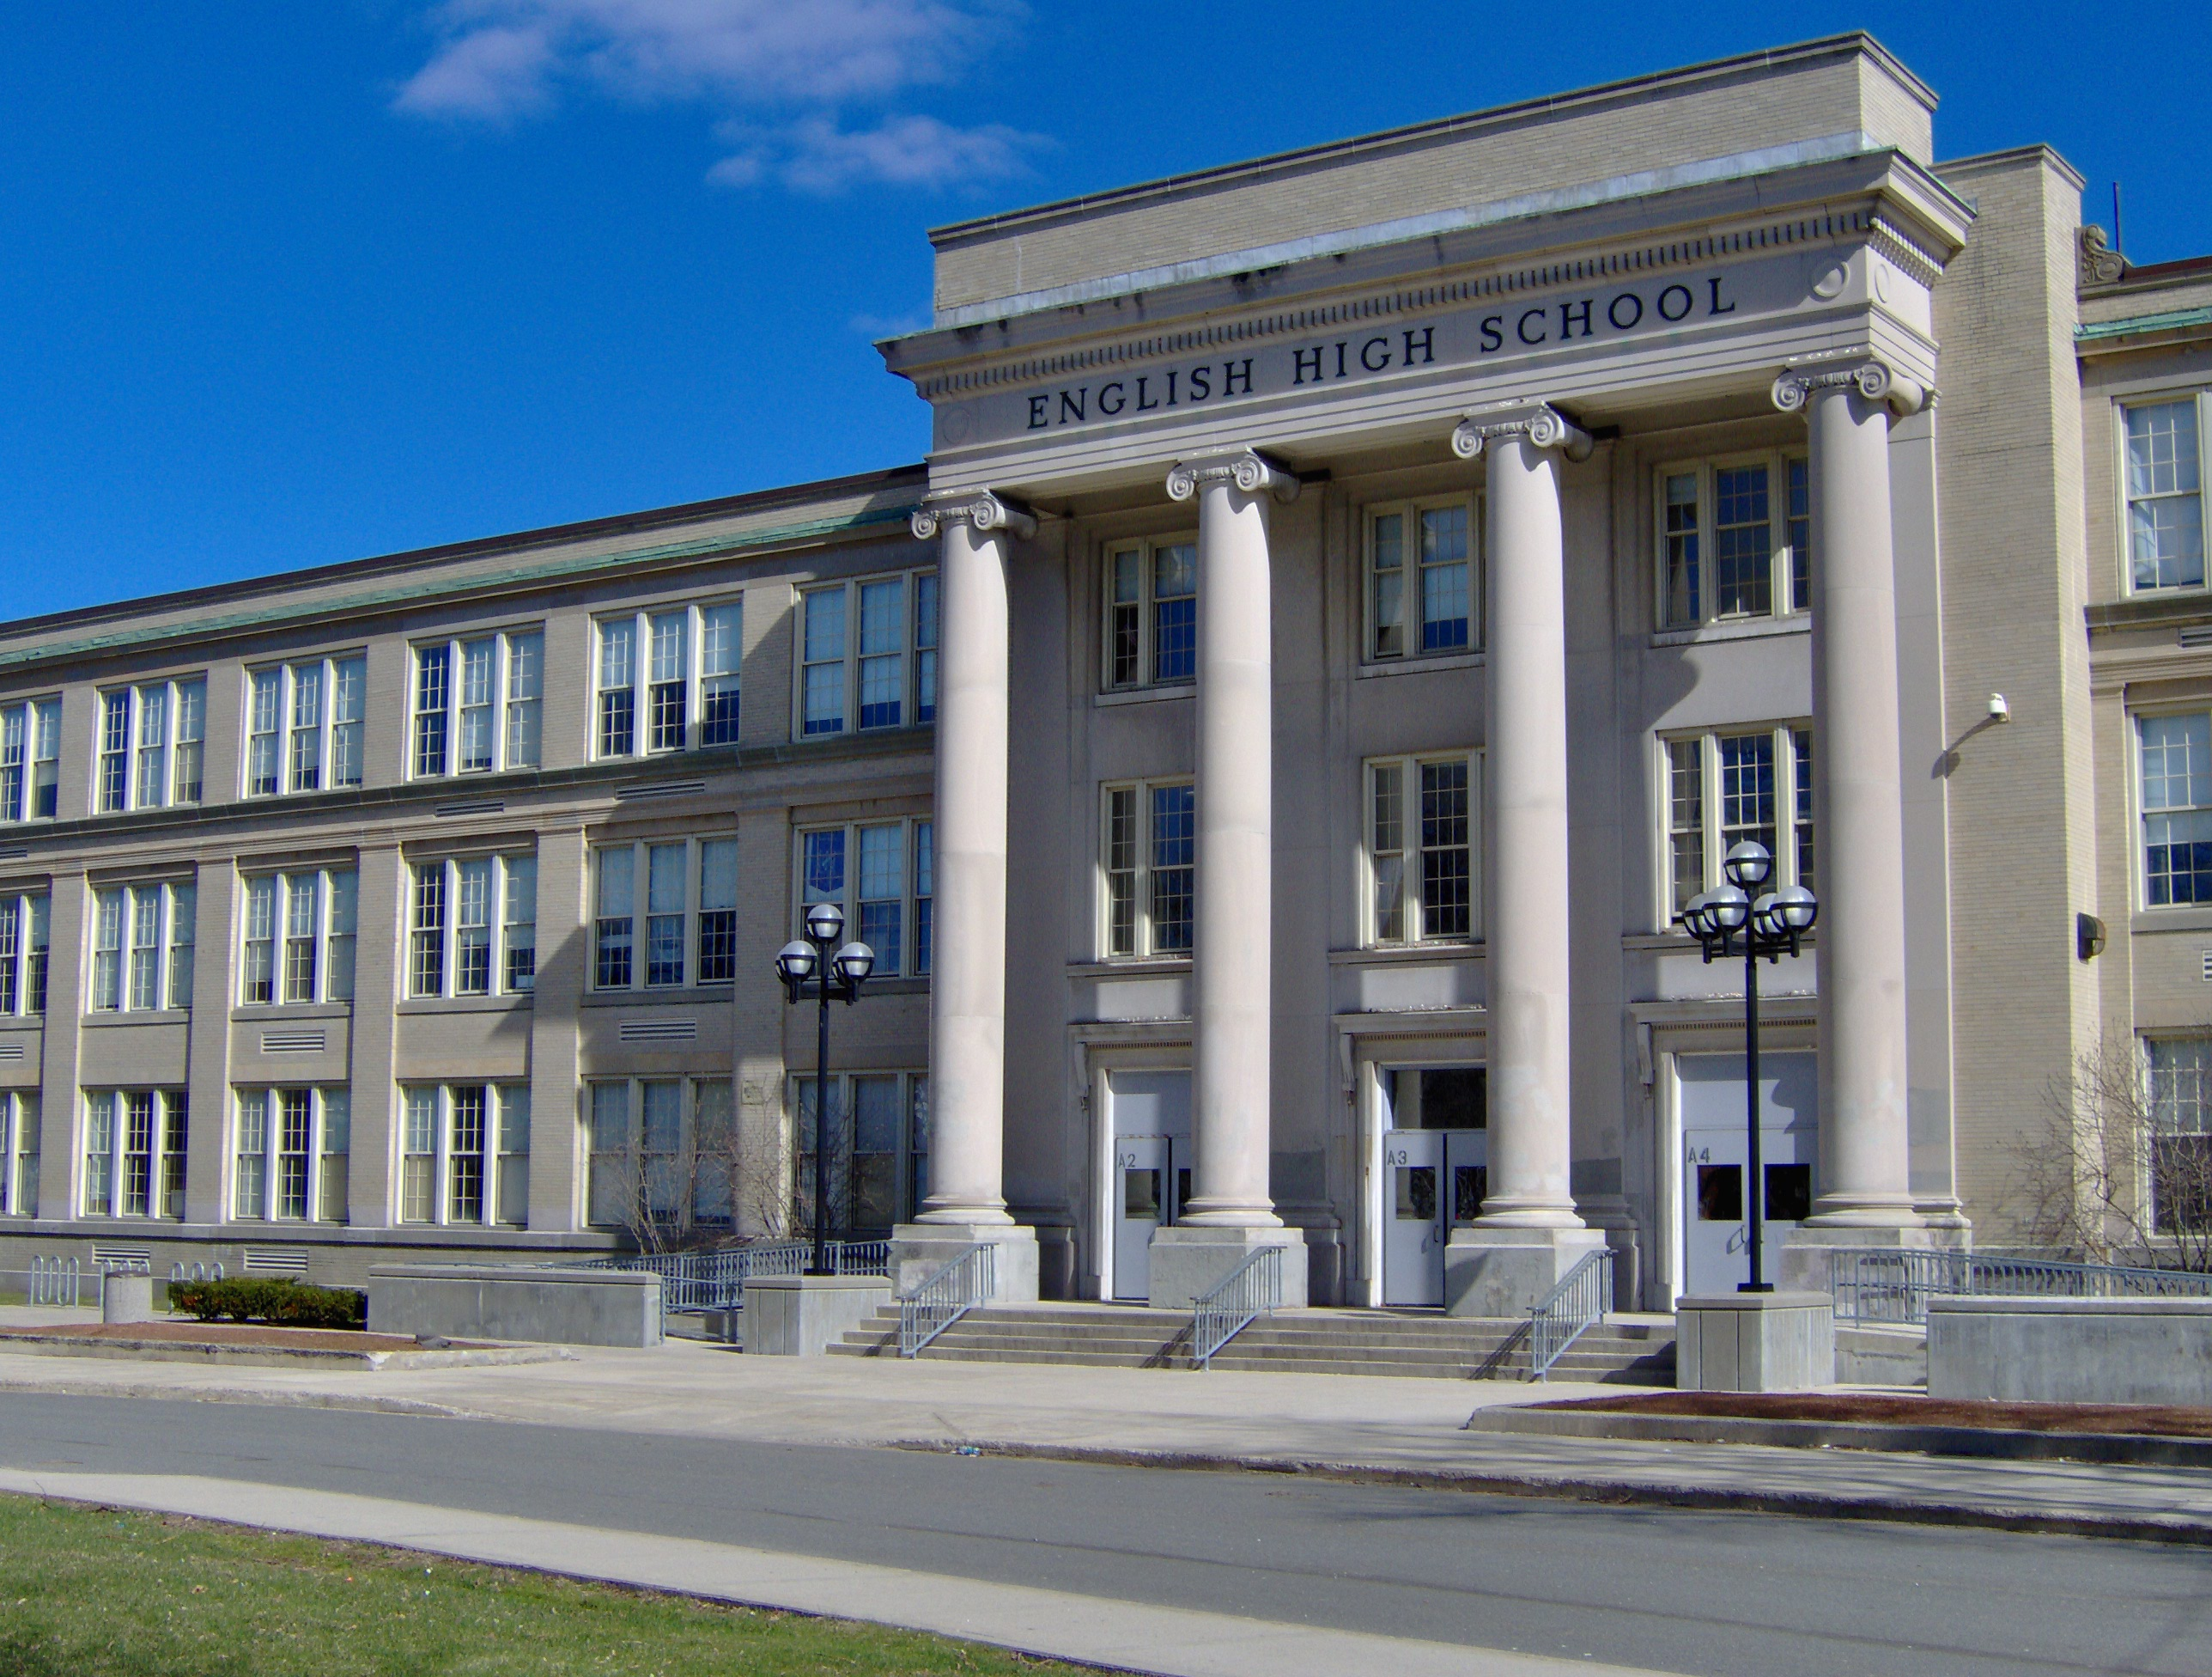
Student Council
Lynn English High School
50 Goodridge Street
Lynn, MA 01902
