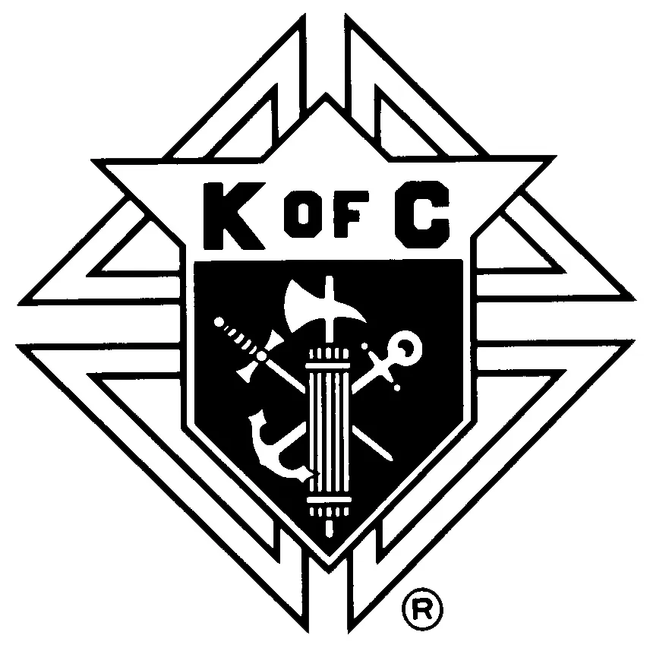
KNIGHTS OF COLUMBUS - VALLADOLID COUNCIL #70 LYNN, MA
177 Lynnfield St, Lynn, MA 01904

2026 - Scholarship Application Form
Valladolid Council #70 Memorial Scholarship
Arthur Cunningham Scholarship
________________________________________________________________________________
Important Information
Please submit the following information to the Lynn Knights of Columbus Scholarship Governing Board by mailing all information to 177 Lynnfield St, Lynn, MA 01904 or by emailing it to Kofc70scholarship@gmail.com by APRIL 15, 2026.
- Completed Application (Please use black ink and write clearly; use additional paper if needed)
- Academic Transcript
- A typewritten essay of 250 to 500 words that answers this year's essay question: “How do you live out the principle of fraternity (fellowship with others) in your life whether in your personal life, at school, at church, or in other aspects of your life?”
________________________________________________________________________________
Personal Application and Contact Information

Full Name:______________________________________________ Date of Birth:______________

Street Address:____________________________________________________________________

City, State, Zip Code:_______________________________________________________________

Email Address:____________________________________________________________________

Telephone Number:________________________________________________________________

Name of High School and Graduation Year:______________________________________________

Have you been accepted or presently enrolled at a College/University/Trade School? ( ) yes ( ) no

If yes, which College/University/Trade School. If not, which schools have you applied to?

________________________________________________________________________________

________________________________________________________________________________

Knights of Columbus Information

Are you a member of the Lynn Knights of Columbus: ( ) yes ( ) no Membership No.:_______________

Are you related to a member/members of the Lynn Knights of Columbus: ( ) yes ( ) no

If so, list their name(s), and their relationship to you:

________________________________________________________________________________

________________________________________________________________________________
Application Questions
1. How do you live out your faith? Or how do you live out your life values?

________________________________________________________________________________

________________________________________________________________________________

________________________________________________________________________________

________________________________________________________________________________

2. How do you serve others in your community (Church, School, or other groups)?

________________________________________________________________________________

________________________________________________________________________________

________________________________________________________________________________

________________________________________________________________________________

3. What organizations are you involved in either at school or outside of school?

________________________________________________________________________________

________________________________________________________________________________

________________________________________________________________________________

________________________________________________________________________________
I attest that the information in the scholarship application is accurate and true.

Signature of Applicant: __________________________________________Date:________________

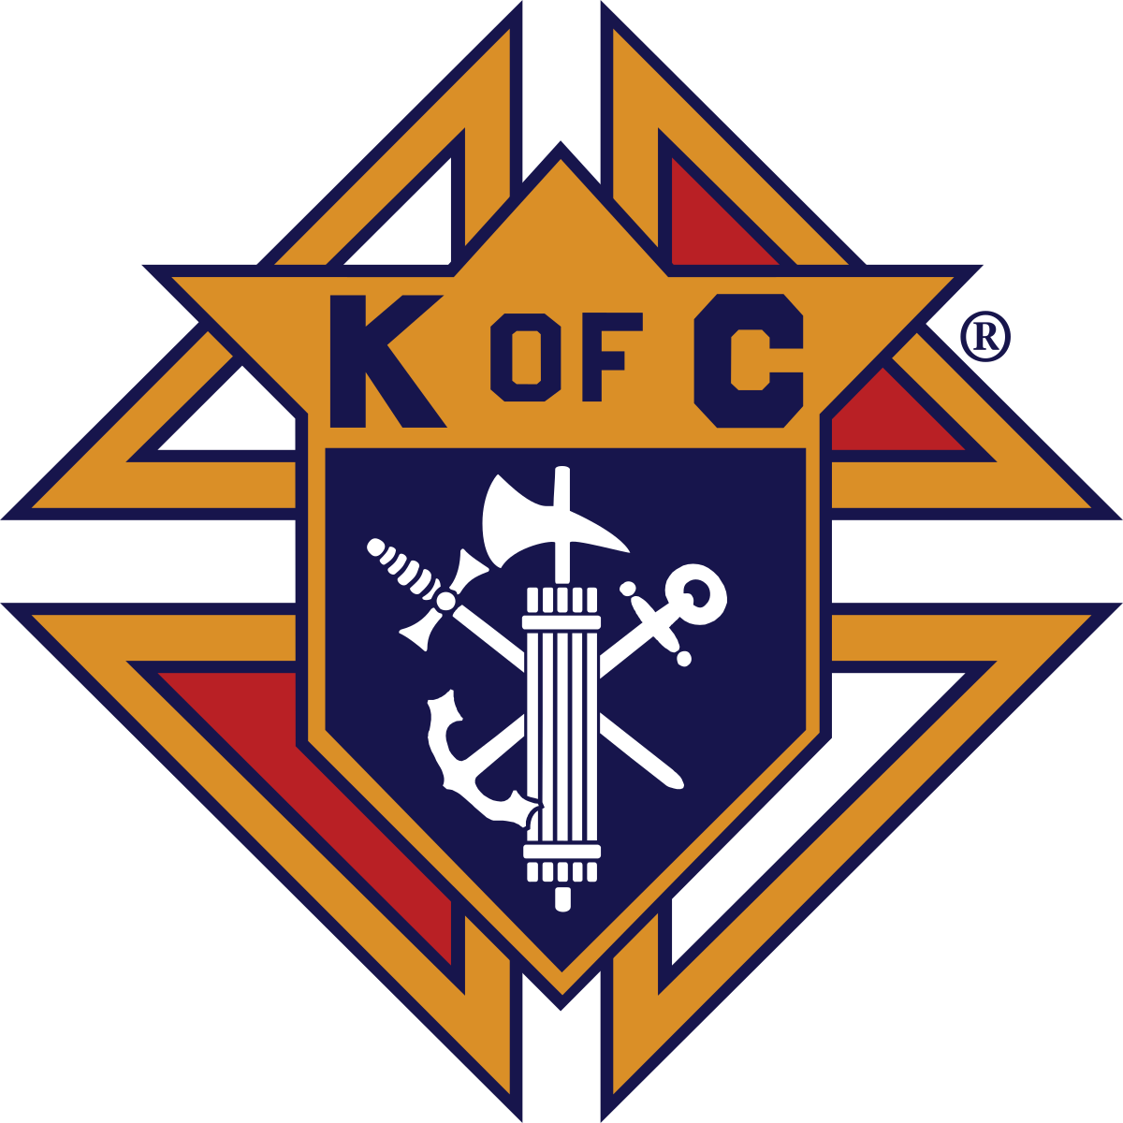
Knights of Columbus
Valladolid Council #70 Lynn MA
Scholarship Governing Board

February 25, 2026

Brother Knights, Guidance Counselors, Parents, and Students,

The scholarship governing board of Valladolid Council wishes to share information about this year’s scholarship program with you.

The scholarship governing board will be granting scholarships from both the Valladolid Council #70 Memorial Scholarship Fund and the Arthur Cunningham Scholarship Fund. Applicants only need to submit one application to be eligible for scholarships from both funds.

Please note that the application has been updated this year, and please take care to submit the proper application. If there are any questions, please reach out to Scholarship Board member John Miner at 978-239-0640 or Kofc70scholarship@gmail.com The only change on the application is the essay question.

The following are the application requirements for both scholarships.
- All applicants must attend, in the upcoming academic year, an accredited institute of higher education which includes technical, vocational, undergraduate, and graduate programs.
- Each applicant must have an unmet financial need.
- Each applicant must submit the following
  - A current Valladolid Scholarship Application that has been completely filled out.
  - A typewritten essay of 250 to 500 words that answers this year's essay question: “How do you live out the principle of fraternity (fellowship with others) in your life whether in your personal life, at school, at church, or in other aspects of your life?”
  - An academic transcript of grades
    - From High School for graduating seniors
    - From College for current college students

Vivat Jesus,

Danny Lemenager John Miner
Board Member Board Member

Fausto Cabrera Brian Darcy
Board Member Board Member

Michael Scarlata
Grand Knight and Board Member

